Children’s Mangrove Art Contest 2026

Dear Friend of the Mangroves,

Mangrove Action Project (MAP) would like to invite children from your country to join in this creative and educational art competition. It is an opportunity for the youth to learn about the vital role Mangroves play in the lives of coastal communities and marine life around the world while letting them explore their imagination and have fun when creating their art pieces.

This 26th annual art contest is an opportunity for participating NGOs to collaborate with teachers and communities, and to develop children’s understanding when thinking about the environment around them. Education about the importance of Mangrove and Coastal ecosystems is critical when affecting long-term change. Children are the next generation of decision makers, and we have the chance to teach them the value of the natural world, giving them a life-long appreciation and respect for their environment.

As always, the selected winning artworks will be published in next year’s art calendar (2027), which will help to raise awareness of mangrove forests while encouraging and listening to the imaginative voices of the next generation. All students submitting artwork will be eligible to receive a printable e- certificate of participation. Winners will receive a calendar, and a certificate showing their great achievement in this year’s Children’s Mangrove Art Contest. As well, selected art will be exhibited in MAP’s virtual gallery.

Please share information about this competition with your local schools, teachers, home schooling groups, youth groups and families. If you do need further ideas of how you or your schools can take part, please don’t hesitate to get in touch with me at: artcontest@mangroveactionproject.org

We look forward to seeing all of your fantastic, colorful artwork!

Yours sincerely,

Monica Gutierrez-Quarto.
Art Contest Project Coordinator
Mangrove Action Project
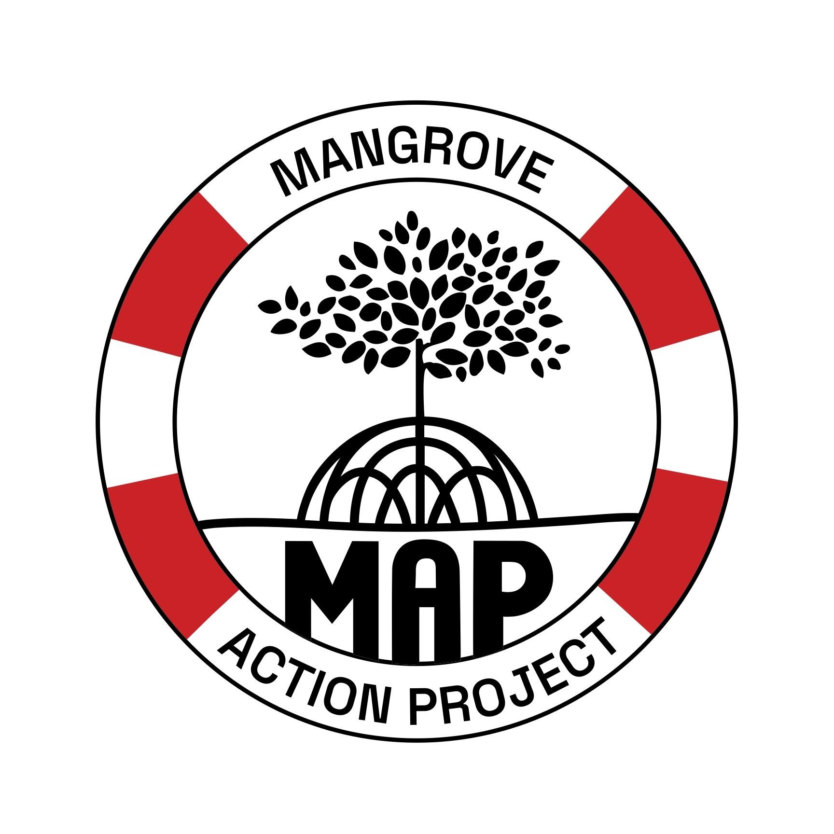

Guidelines for Artwork Submissions

The themes of this year’s competitions are the following. You can choose any one or a combination of these.
- Animals of the Mangroves
- People and Community Living in the Mangrove Forest.
- Threats to the Mangroves, or Solutions.

Please, carefully read the instructions as any artworks not following the guidelines will, unfortunately, not be accepted. If you have any questions regarding the competition or artwork to submit. Please contact Monica at: artcontest@mangroveactionproject.org

Submissions open: April 22, 2026

Contest Deadline: August 31, 2026

We would like the participants to respond to any of these three questions in a few sentences as well as sending their submission.

1) What have you learned about mangroves?

2) What are the threats to the mangroves today?

3) How does garbage and marine debris affect mangroves?

Technique: We would like lots of COLORFUL work please; no black and white! Paint, color pencil, ink, collage, pastel, crayons, etc. are all accepted.
This can be on canvas or paper.

Dimensions: A3 paper (42cm x30 cm or 18in x12 in)
Format: LANDSCAPE: this means the artwork should have the longer length across and the shorter length up to down. Portrait format will be rejected.

Age Limit: From 7-16 years old

One submission per artist.

Digital Art or AI Art is not accepted.

Digital Submission: Please send a digital file. The artwork should be scanned, or a photo taken at minimum 300 dpi at a minimum resolution of 3,712 x 2,784, as a jpg file. The submitted files need to be named using the name,age and country of the student. For example, Carla May is from China, and she is sending a photo that should be named Carla May/ Age 8/China/ Contest 2026
Awards: Winners will receive a calendar and hard copy certificate for achievement and art will be featured in our online virtual gallery. All participants will receive an e-printable participatory certificate to be printed and filled in with the complete name of the participant student by the teacher, local organization, guardian, or parent.
Artist Identification: When submitting the artwork please include the following information that appears in the box below as a separate word document file, or in the email. Files must be sent to us via WeTransfer. (wetransfer.com) Please send submissions to: artcontest@mangroveactionproject.org
Student Information sheet
Full Name:

Artist’s Age:

School name:

Contact email:

Country:

I authorize MAP to use the image submitted for educational uses in website, publications, social media, and promotion products.

